[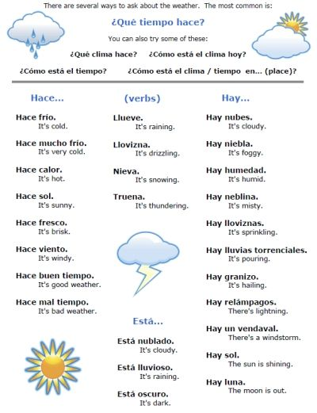](https://www.google.com/url?sa=i&rct=j&q=&esrc=s&source=images&cd=&cad=rja&uact=8&ved=0CAcQjRxqFQoTCIqm_5vD2McCFciODQodVdwBUA&url=https%3A%2F%2Fwww.pinterest.com%2Fpin%2F3659243420335343%2F&psig=AFQjCNGsIWjeXpdiEZ-yT4mgSYO5UCIurw&ust=1441289286237462)