[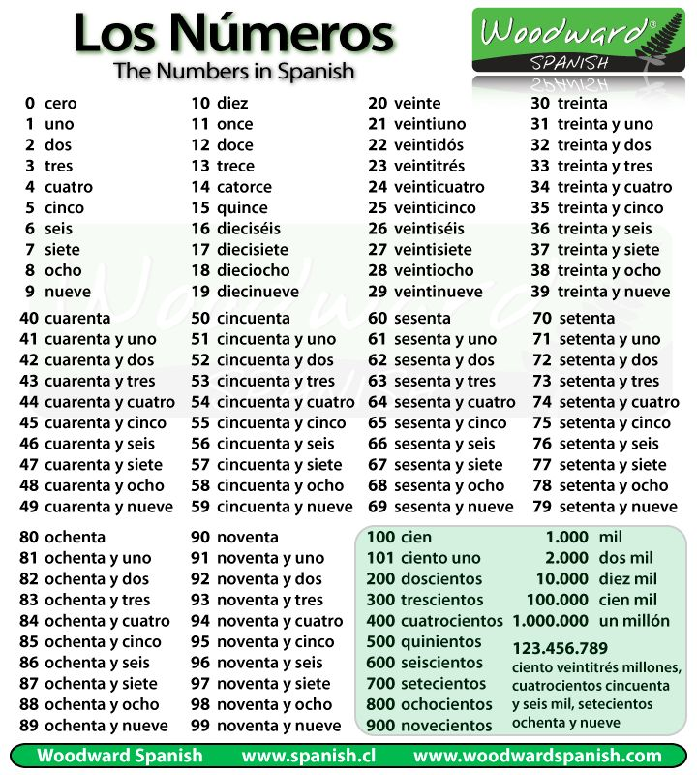](https://www.google.com/url?sa=i&rct=j&q=&esrc=s&source=images&cd=&cad=rja&uact=8&ved=0CAcQjRxqFQoTCLaBzJ7B2McCFc_0gAod9_4Kpw&url=https%3A%2F%2Fwww.pinterest.com%2Fpin%2F328129522827455659%2F&psig=AFQjCNGVT1_WUuKxuaGs1-Fsx-2Kb4H6hQ&ust=1441288713424103)